Animated Dynamic VDU By Electric Wolf

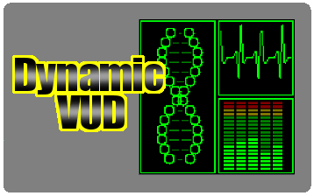

Dynamic VDU is a collection of animated dynamic monitors, That will show a range of alertness form no alert - all is green to full alert - were most is red

Any number of effects can be placed on to one texture.
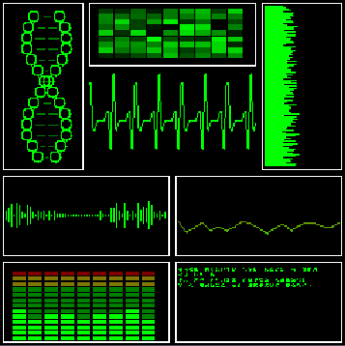

How to set-up for any game
Follow the steps below to use in any game.
- Select the base prefab: From the folder Assets\eWolf\eWolfDynamicVDU\Prefabs\ Select the size of the texture you wish to use(this can be changed any time later) Drag it in to the scene and place it where you need it.
- Define the effect: In the Inspector, use the Effect drop download list to select the effect from the list.
- Define the size: Use the Rect setting to define the size as a percentage of the image. a width of 1 is the full width of the texture, 0.5 is half the width. And you can tick Apply Border if you want to have a border around the effect.
- Extra Effects: If you wish to have more then one effect per texture, Increase the Size and repeat the previous two steps. However many time you like.
- Colour and speed: You can update the colours used for the textures. You can change the speed of the effect by updating Interval

Updating the effect at runtime
You can change the Alert value at run time by using the
go.SendMessage(MonitorDefines.UpdateAlertMessage, newAlert);
Where go is the monitor object.

You can pause an un-pause the effect with
go.SendMessage(MonitorDefines.SetPauseMessage, true);
and
go.SendMessage(MonitorDefines.SetPauseMessage, false);
Where go is the monitor object.
You can find UpdateAlerts.cs as an example of the above code.

Examples of all effects on different textures sizes
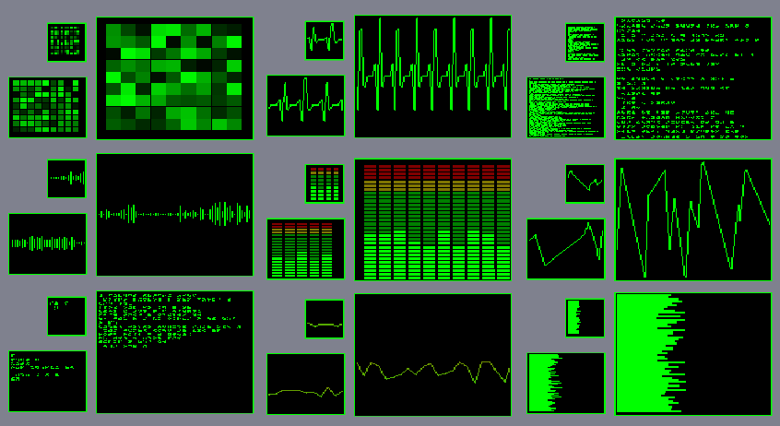

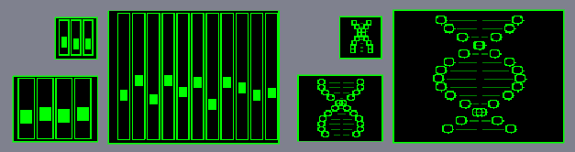

The details here are also on my web site
http://electricwolf.co.uk/

If you need any more help please email me at Wolf@electricwolf.co.uk

